

*Project DAP391m*

# **Attendance system using mtcnn and facenet and anti cheating with yolov8 and spoof**

Nguyễn Quốc Huy

Mai Việt Khánh

Nguyễn Gia Hiển

**Advisor:** Phan Duy Hùng

**Abstract:** Face recognition-based automatic attendance systems are becoming increasingly popular in educational and business environments due to their high accuracy and efficiency. This study proposes a face recognition system that uses FaceNet combined with SVM to authenticate student identities in the classroom. Data is collected from personal camera systems and processed through data augmentation techniques to improve accuracy. The system also incorporates fraud detection methods using YOLOv8 and anti-spoofing checking using CNN. The results show that the proposed method achieves high accuracy, which is suitable for the requirements of automatic attendance in practice.

**Keywords**: Face Recognition, Attendance System, FaceNet, SVM, YOLOv8, Deep Learning, Anti-Spoofing

## **1. Introduction**

### 1.1. Problems and Motivation

Traditional attendance in educational institutions and enterprises is often time-consuming, prone to errors and fraud. Automatic attendance systems using face recognition help to solve these problems by using computer vision and deep learning technology to identify identities quickly and accurately [6]. Currently, many studies have demonstrated the effectiveness of deep learning models in face recognition, especially FaceNet, ArcFace and MTCNN [1][2]. However, the implementation of the actual attendance system still faces many challenges, including high computational resource requirements and accuracy affected by lighting conditions and face rotation angles [3][5]. Some systems have used cloud platforms to improve processing performance and scalability, especially deploying on Google Cloud Platform to offload local computation [1].

### 1.2. Related Works

Many studies have proposed different methods to improve the accuracy of automatic attendance systems:

* FaceNet + SVM: Used in some studies with an accuracy of 99.6% on the test dataset [3].
* ArcFace with RetinaFace: Proven to have high accuracy but requires large computational resources [1].
* MTCNN + FaceNet: Optimizing face recognition in unstable lighting conditions [4].
* Cloud-based systems: Some studies deploy the system on Google Cloud to increase performance and scalability [1].
* Using Transfer Learning: Some systems leverage Deep Transfer Learning to improve face recognition when data is limited [7].
* Face recognition combined with geolocation: Some studies have integrated Machine Learning with location information for more accurate attendance authentication [9].

### 1.3. Contribution

This attendance system uses personal photo data in the classroom, taken from the personal camera system. We apply advanced facial recognition algorithms to build a highly accurate, resource-saving, and scalable system. At the same time, the system also incorporates fraud detection methods (such as using YOLO to detect phones in photos) to ensure the accuracy of attendance [10]. In addition, we also consider anti-fake facial methods using Deep Learning to prevent forms of cheating such as using photos or videos instead of real faces [8]. In educational institutions and enterprises, attendance is often time-consuming, prone to errors and fraud. The automatic attendance system using facial recognition solves these problems by using computer vision and deep learning technology to quickly and accurately identify identities. Currently, many studies have demonstrated the effectiveness of deep learning models in face recognition, especially FaceNet, ArcFace, and MTCNN [1][2]. However, the implementation of time attendance systems in the real world still faces many challenges, including high computational resource requirements and accuracy affected by lighting conditions and face rotation angles [3].

## 2. Data Collection

### 2.1. Data Acquisition

Data is collected from personal cameras, student portraits, combined with photos collected in the classroom environment. This data will be cleaned and processed before being fed into the facial recognition system.

### 2.2. Description

Data includes student facial images from multiple angles, helping to improve recognition accuracy. Photos are processed to standardize size and lighting, and remove invalid images.

### 2.3. Statistics

The data includes 4 people, each with 50 photos taken from their personal cameras. The table below shows a list of student ID numbers, full names, and the corresponding number of photos:

| **Mã số sinh viên** | **Họ và tên** | **Số lượng ảnh** |
| --- | --- | --- |
| HE180079 | Mai Việt Khánh | 50 |
| HE186603 | Nguyễn Quốc Huy | 50 |
| HE187161 | Nguyễn Quý Quyền | 50 |
| HE190303 | Nguyễn Gia Hiển | 50 |

### 

### 

### 

### 

### 2.4. Sample Data

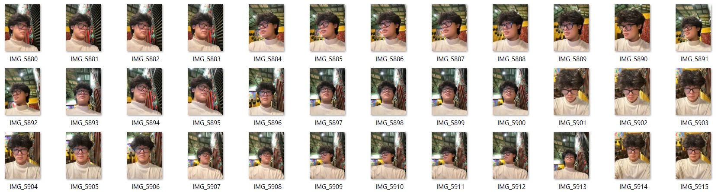

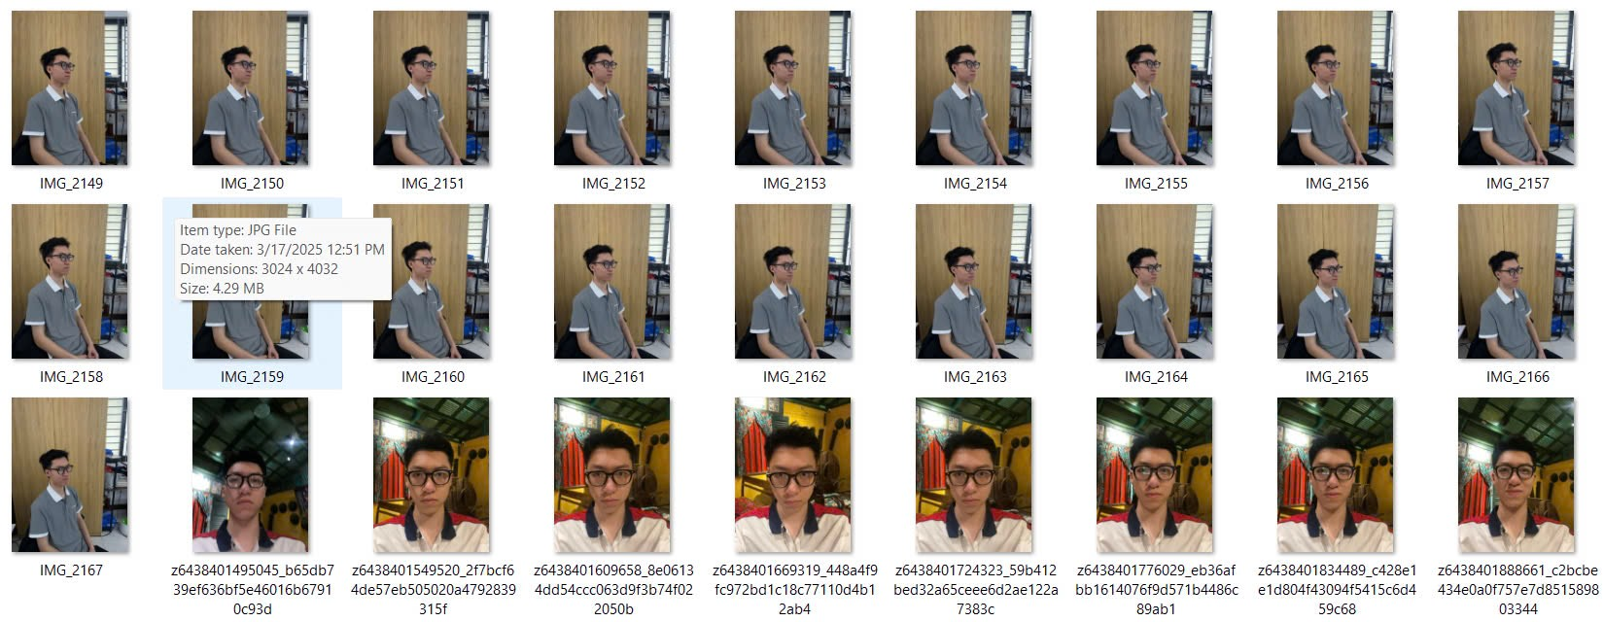

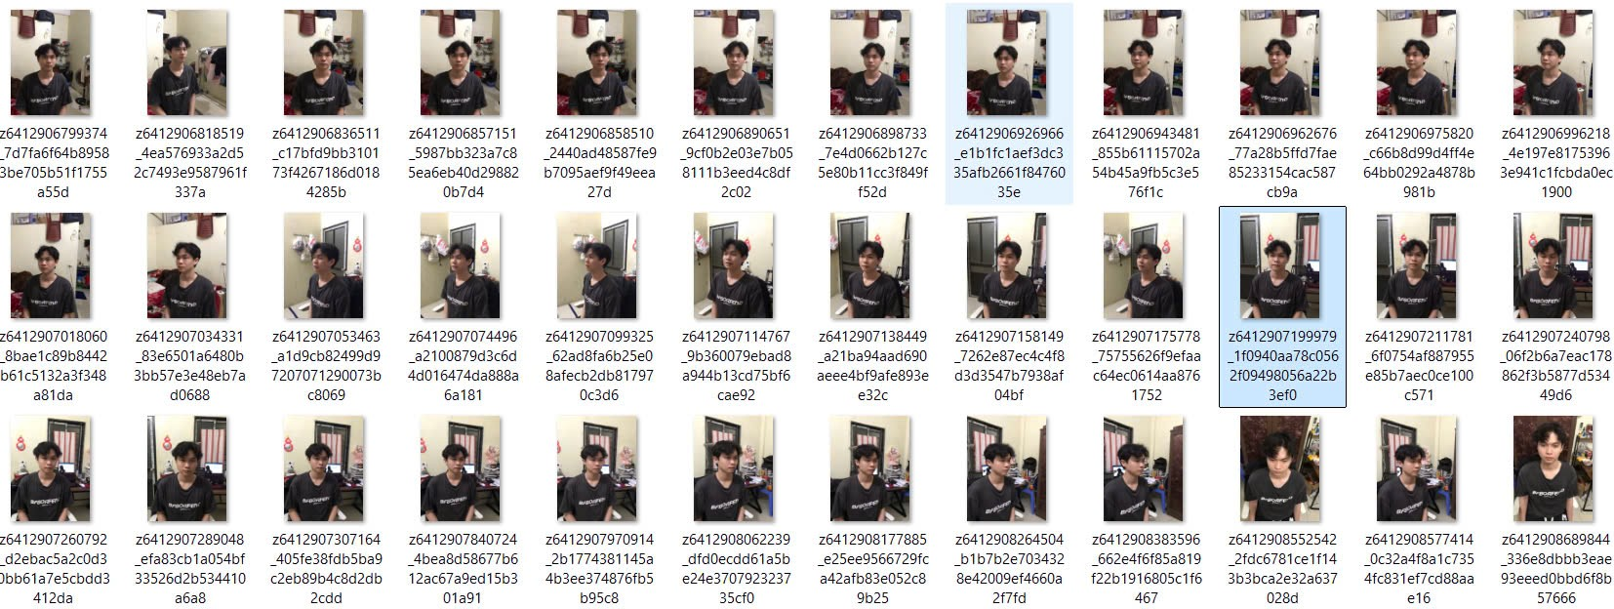

### 2.5. Data Processing

During the system construction, the original image data is enhanced to ensure that the deep learning model can generalize better. The processing steps applied include:

* Rotate the image within ±15 degrees to simulate different facial angles.
* Gaussian blur to test the model's robustness to low-quality images.
* Randomly adjust the brightness and contrast to reflect real-life lighting conditions.
* Add Gaussian noise to increase the diversity of the data.
* Divide the dataset according to the ratio: Train (80%), Validation (10%), Test (10%) to ensure objectivity when evaluating the model.

## 3. Methodology

After analyzing related studies, we found that most of the current systems focus on improving the accuracy of face recognition but have not fully solved the problem of detecting cheating in real classrooms. For example, the study of Nyein & Oo (2021) achieved 99.6% accuracy with FaceNet + SVM [3], Asmara et al. (2022) deployed the system on the Google Cloud platform with ArcFace achieving 100% accuracy under ideal conditions [1], while studies such as Ramalakshmi et al. (2021) used MTCNN to increase the stability of face recognition in a classroom environment [4]. However, these studies have not combined cheating checking, anti-spoofing of faces and face recognition in an integrated system. From there, we developed a system that can process in real time, check for cheating devices (phones), prevent face forgery, identify students, and record attendance completely.

After completing the data collection phase and reviewing previous studies, we built and deployed a real attendance system with main components such as fraud detection (detecting fake devices and faces), student identification, and recording attendance information. The implemented Python source code files fully performed the above functions, using many modern technologies such as YOLOv8, FaceNet, LabelEncoder, and anti-spoofing face models. In addition, during the actual testing process, the system was also integrated with the iVCam application to use the phone camera as a high-quality video input source to replace the default webcam of the laptop. This section details the system architecture and data processing process during the attendance process.

### 3.1. System Overview

The attendance system is built with three main components:

* Fraud detection: Use YOLOv8 to detect mobile devices and anti-spoof model (anti-spoof-mn3.onnx) to check real or fake faces.
* Student recognition: Use MTCNN to detect faces, FaceNet to extract features, and SVM to classify student identities.
* Attendance recording: Save time, date, student ID and photo to CSV file and image folder.

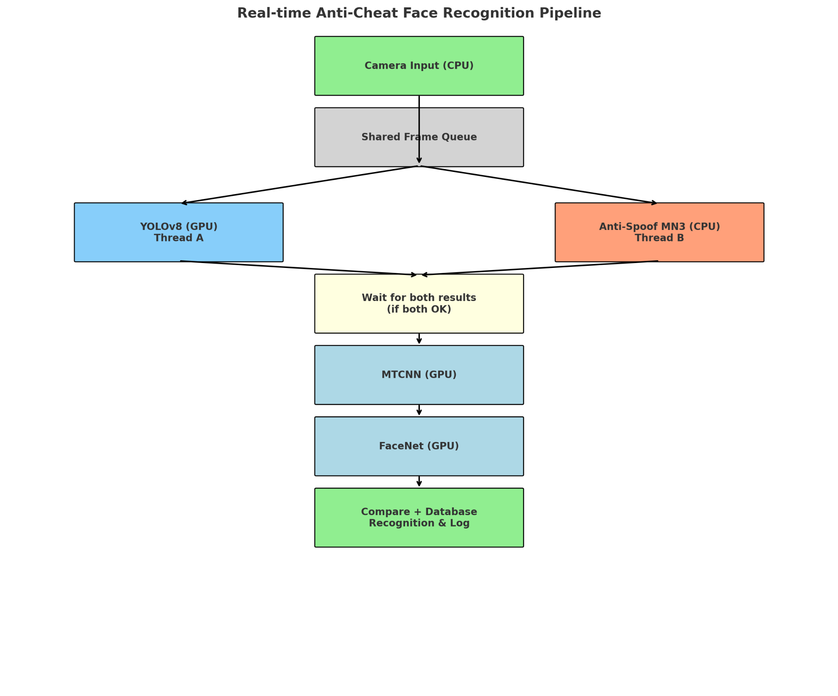

### 3.2. Anti-Spoofing and Fraud Detection

* The YOLOv8 model is used to detect phones with class ID = 67, to prevent students from using images on the device.
* The anti-spoof-mn3.onnx model is used to identify real or fake faces with high accuracy and the authentication threshold is set to 0.45.
* Only when 10 consecutive frames do not contain fraud and the face is real, the system will proceed to identify students.

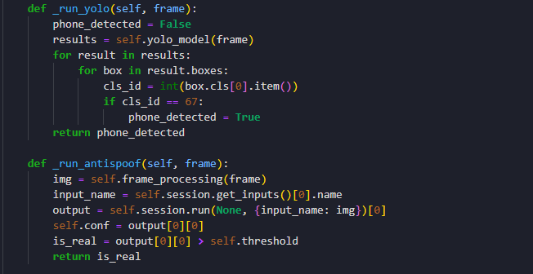

### 3.3. Face Detection and Recognition

* The system uses MTCNN to detect faces.
* Use FaceNet (Inception Resnet 1) trained on VGGFace2 to extract 512-dimensional embedding.
* The embedding is classified using a pre-trained SVM model.
* The labeled data uses LabelEncoder to map student codes.

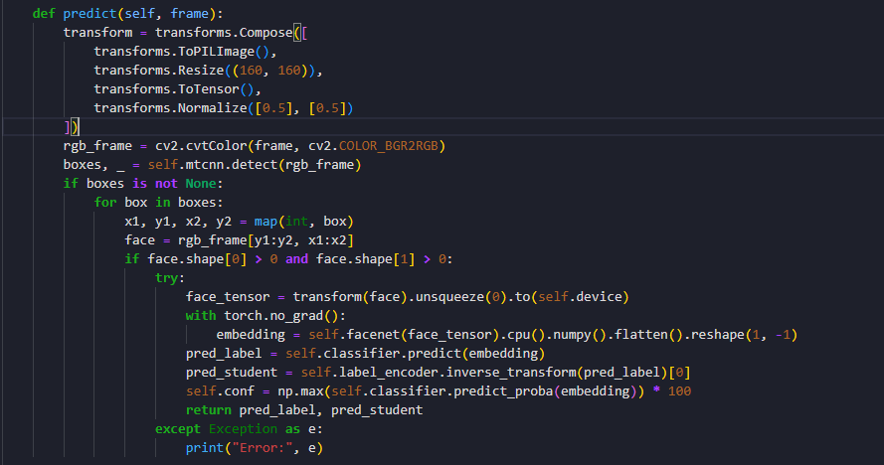

### 3.4. Attendance Logging

* When the student is authenticated, the system will:
  + Display the student name, reliability.
  + Save the photo with real time to the photo folder.
  + Save the log including: Student ID, Date, Time, Status and photo path to CSV file (attendance_log.csv).

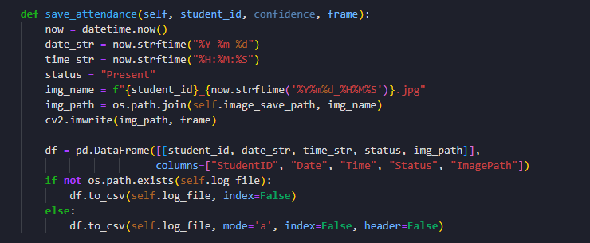

### 3.5. Multi-threaded Execution

* To ensure real-time processing speed, the system uses ThreadPoolExecutor to run YOLO and anti-spoof in parallel.
* Each frame is processed at an average of 25-30 FPS on the GPU.

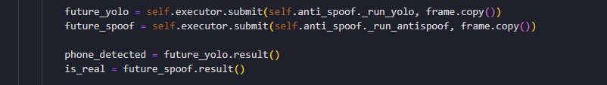

### 3.6. Conditions for Valid Attendance

* If a fake face or mobile device is detected, the frame will be rejected.
* If there are 10 consecutive valid frames, student recognition will be performed.

### 3.7. Performance Analysis and Results

After the actual testing, the system achieved an average processing speed of about 30–40 FPS on a computer with a GPU, ensuring real-time operation. The detection of fake faces and mobile devices achieved an almost absolute success rate in the test cases in a standard classroom.

### 3.8. Model Results

| Evaluation Components | Description | Estimated Results |
| --- | --- | --- |
| Anti-Spoofing (ONNX MN3) | Real/Fake Face Identification | 90.5% accuracy |
| Phone Detection (YOLOv8) | Phone Detection (class 67) | ~95% precision |
| Face Recognition (FaceNet) | Face Recognition | ~96% accuracy |

## References

[1] Asmara, R.A., et al. (2022). Face Recognition Using ArcFace and FaceNet in Google Cloud Platform.

[2] Bankar, R., et al. (2022). Face Recognition Using FaceNet Deep Learning Network.

[3] Nyein, T., & Oo, A.N. (2021). University Classroom Attendance System Using FaceNet and SVM.

[4] Ramalakshmi, E., et al. (2021). Facial Recognition Attendance System using MTCNN and FaceNet.

[5] Khalkar, O., et al. (2024). Automatic Attendance System, Using Face Detection and Machine Learning.

[6] Gowda, D.H.L., et al. (2020). Face Recognition Based Attendance System.

[7] Alhanaee, K., et al. (2021). Face Recognition Smart Attendance System using Deep Transfer Learning.